NAME: RAHUL PANDEY ROLL NO: 244CA039

1. Create the following tables with the following attributes and constraints on them
a. Employee (Fname, mname, lname, Ssn, Bdate, address, gender, salary, Super_Ssn, Dept_num) Lname, Ssn, Dept_num should be not null.

CREATE TABLE Employee (
Fname VARCHAR(50),
Mname VARCHAR(50),
Lname VARCHAR(50) NOT NULL,
Ssn CHAR(9) NOT NULL PRIMARY KEY,
Bdate DATE,
Address VARCHAR(255),
Gender CHAR(1),
Salary DECIMAL(10,2),
Super_Ssn CHAR(9),
Dept_num INT NOT NULL
);

b. Department (Dept_num, Dept_name, Mgr_Ssn, Mgr_startdate) Dept_name should be unique
CREATE TABLE Departments (
Dept_num INT PRIMARY KEY,
Dept_name VARCHAR(100) UNIQUE NOT NULL,
Mgr_Ssn CHAR(9),
Mgr_startdate DATE,
FOREIGN KEY (Mgr_Ssn) REFERENCES Employee(Ssn)
);

c. Department_locations (Dept_num, location) Dept_num and location both are primary key Dept_num is foreign key
CREATE TABLE Department_Locations (
Dept_num INT,
Location VARCHAR(100),
PRIMARY KEY (Dept_num, Location),
FOREIGN KEY (Dept_num) REFERENCES Departments(Dept_num)
);

d. Project (Proj_num, Proj_name, Proj_location, Dept_num)
CREATE TABLE Project (
Proj_num INT PRIMARY KEY,
Proj_name VARCHAR(100),
Proj_location VARCHAR(100),
Dept_num INT, FOREIGN KEY (Dept_num) REFERENCES Departments(Dept_num)
);

e. Employee_Project (Ssn, Proj_num, Hours)
CREATE TABLE Employee_Project (
Ssn CHAR(9),
Proj_num INT,
Hours DECIMAL(5,2),
PRIMARY KEY (Ssn, Proj_num),
FOREIGN KEY (Ssn) REFERENCES Employee(Ssn),
FOREIGN KEY (Proj_num) REFERENCES Project(Proj_num)
);

f. Dependent (Ssn, Dept_name, gender, bdate, relationship)

CREATE TABLE Dependent (
Ssn CHAR(9),
Dept_name VARCHAR(100),
Gender CHAR(1),
Bdate DATE,
Relationship VARCHAR(50),
PRIMARY KEY (Ssn, Dept_name),
FOREIGN KEY (Ssn) REFERENCES Employee(Ssn)
);

2. Add two column blood group and hobbies to employee table.
ALTER TABLE Employee ADD Blood_Group VARCHAR(10);
ALTER TABLE Employee ADD COLUMN Hoconvert the varca\u\\bbies VARCHAR(255);

3. Increase the size of column blood group to 15 to the employee table.
ALTER TABLE Employee MODIFY COLUMN Blood_Group VARCHAR(15);

4. Drop column hobbies from the employee table.
ALTER TABLE Employee DROP COLUMN Hobbies;

5. Rename Employee Table to Employee_details.
ALTER TABLE Employee RENAME TO Employee_details;

6. Insert atleast five records in each table.
INSERT INTO Employee_details
VALUES ('Amit', 'Kumar', 'Sharma', '100000001', to_date('1985-03-15', 'YYYY-MM-DD'), 'Delhi, India', 'M', 45000.00, NULL, 1, 'B+');

INSERT INTO Employee_details VALUES ('Amit', 'Kumar', 'Sharma', '100000001', to_date('1985-03-15', 'YYYY-MM-DD'), 'Delhi, India', 'M', 45000.00, NULL, 1, 'B+');
INSERT INTO Employee_details VALUES ('Priya', 'Rani', 'Verma', '100000002', to_date('1990-07-25', 'YYYY-MM-DD'),'Mumbai, India', 'F', 52000.00, NULL, 2, 'O+');
INSERT INTO Employee_details VALUES ('Rajesh', 'Singh', 'Yadav', '100000003', to_date('1982-05-12','YYYY-MM-DD'), 'Kolkata, India', 'M', 48000.00, NULL, 3, 'A-');
INSERT INTO Employee_details VALUES ('Sneha', 'Anjali', 'Patel', '100000004', to_date( '1995-09-08','YYYY-MM-DD'), 'Chennai, India', 'F', 35000.00, NULL, 1, 'AB+');
INSERT INTO Employee_details VALUES ('Vikram', 'Raj', 'Mishra', '100000005', to_date( '1988-12-20','YYYY-MM-DD'), 'Bangalore, India', 'M', 60000.00, NULL, 2, 'B-');
INSERT INTO Employee_details VALUES ('Pooja', 'Devi', 'Sinha', '100000006', to_date( '1992-06-18', 'YYYY-MM-DD'),'Hyderabad, India', 'F', 41000.00, NULL, 3, 'O-');
INSERT INTO Employee_details VALUES ('Arun', 'Prakash', 'Gupta', '100000007', to_date( '1980-11-30', 'YYYY-MM-DD'),'Pune, India', 'M', 75000.00, NULL, 4, 'A+');
INSERT INTO Employee_details VALUES ('Rohit', 'Kumar', 'Thakur', '100000008', to_date( '1987-04-22', 'YYYY-MM-DD'),'Jaipur, India', 'M', 42000.00, NULL, 1, 'B+');
INSERT INTO Employee_details VALUES ('Swati', 'P', 'Joshi', '100000009', to_date( '1993-08-14','YYYY-MM-DD'), 'Ahmedabad, India', 'F', 39000.00, NULL, 2, 'AB-');
INSERT INTO Employee_details VALUES ('Naveen', 'Chandra', 'Reddy', '100000010', to_date( '1984-10-10', 'YYYY-MM-DD'),'Lucknow, India', 'M', 50000.00, NULL, 3, 'O+');

INSERT INTO Departments VALUES (1, 'HR', '100000001', to_date('2015-06-01''YYYY-MM-DD'));
INSERT INTO Departments VALUES (2, 'Finance', '100000002', to_date('2014-08-15','YYYY-MM-DD'));
INSERT INTO Departments VALUES (3, 'IT', '100000003', to_date('2016-07-10','YYYY-MM-DD'));
INSERT INTO Departments VALUES (4, 'Marketing', '100000004', to_date('2017-02-20','YYYY-MM-DD'));
INSERT INTO Departments VALUES (5, 'Sales', '100000005',to_date( '2018-03-25','YYYY-MM-DD'));
INSERT INTO Departments VALUES (6, 'Operations', '100000006', to_date('2016-05-30','YYYY-MM-DD'));
INSERT INTO Departments VALUES (7, 'R', '100000007', to_date('2019-09-12','YYYY-MM-DD'));
INSERT INTO Departments VALUES (8, ' Support', '100000008', to_date('2020-01-05','YYYY-MM-DD'));
INSERT INTO Departments VALUES (9, 'Logistics', '100000009', to_date('2013-12-11','YYYY-MM-DD'));
INSERT INTO Departments VALUES (10, 'Legal', '100000010', to_date('2021-06-18','YYYY-MM-DD'));

INSERT INTO Department_Locations VALUES (1, 'Delhi');
INSERT INTO Department_Locations VALUES (2, 'Mumbai');
INSERT INTO Department_Locations VALUES (3, 'Kolkata');
INSERT INTO Department_Locations VALUES (4, 'Chennai');
INSERT INTO Department_Locations VALUES (5, 'Bangalore');
INSERT INTO Department_Locations VALUES (6, 'Hyderabad');
INSERT INTO Department_Locations VALUES (7, 'Pune');
INSERT INTO Department_Locations VALUES (8, 'Jaipur');
INSERT INTO Department_Locations VALUES (9, 'Ahmedabad');
INSERT INTO Department_Locations VALUES (10, 'Lucknow');

convert the varca\u\\

INSERT INTO Project VALUES (101, 'Recruitment System', 'Delhi', 1);
INSERT INTO Project VALUES (102, 'Financial Audit', 'Mumbai', 2);
INSERT INTO Project VALUES (103, 'Cloud Migration', 'Kolkata', 3);
INSERT INTO Project VALUES (104, 'Ad Campaign', 'Chennai', 4);
INSERT INTO Project VALUES (105, 'Product Sales', 'Bangalore', 5);
INSERT INTO Project VALUES (106, 'Supply Chain', 'Hyderabad', 6);
INSERT INTO Project VALUES (107, 'AI Research', 'Pune', 7);
INSERT INTO Project VALUES (108, 'Customer Portal', 'Jaipur', 8);
INSERT INTO Project VALUES (109, 'Inventory Management', 'Ahmedabad', 9);
INSERT INTO Project VALUES (110, 'Compliance Audit', 'Lucknow', 10);

INSERT INTO Employee_Project VALUES ('100000001', 101, 30);
INSERT INTO Employee_Project VALUES ('100000002', 102, 40);
INSERT INTO Employee_Project VALUES ('100000003', 103, 35);
INSERT INTO Employee_Project VALUES ('100000004', 104, 25);
INSERT INTO Employee_Project VALUES ('100000005', 105, 20);
INSERT INTO Employee_Project VALUES ('100000006', 106, 45);
INSERT INTO Employee_Project VALUES ('100000007', 107, 50);
INSERT INTO Employee_Project VALUES ('100000008', 108, 30);
INSERT INTO Employee_Project VALUES ('100000009', 109, 40);
INSERT INTO Employee_Project VALUES ('100000010', 110, 35);
convert the varca\u\\

INSERT INTO Dependent VALUES ('100000001', 'HR', 'F', to_date('1960-05-15','YYYY-MM-DD'), 'Spouse');
INSERT INTO Dependent VALUES ('100000002', 'Finance', 'M', to_date('1995-08-25', 'YYYY-MM-DD'),'Child');
INSERT INTO Dependent VALUES ('100000003', 'IT', 'F', to_date('1965-09-18', 'YYYY-MM-DD'),'Parent');
INSERT INTO Dependent VALUES ('100000004', 'Marketing', 'M', to_date('1970-12-10','YYYY-MM-DD'), 'Spouse');
INSERT INTO Dependent VALUES ('100000005', 'Sales', 'F', to_date('1985-04-22','YYYY-MM-DD'), 'Child');
7. Give 1000 rupees bonus to each employee.
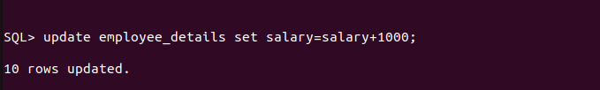
8. Increase the salary of the employees having salary <5000 by 500 rupees.
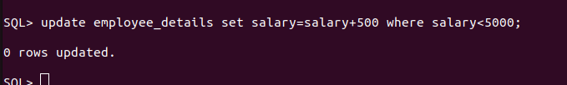
9. Give 100 rupees bonus to employees having salary less than 10000 rupees and birth date
before 1990.
10. Give 100 rupees bonus to employees having salary less than 10000 rupees or birth date
before 1990.
11. Give 100 rupees bonus to employees having salary between 1000 to 5000 rupees and birth
date before 1990.convert the varca\u\\
12. Give 100 rupees bonus to employees having salary between 1000, 3000 and 5000 rupees.
13. Update phone number with 0000 where NULL.
14. Give 100 rupees bonus to employees having salary not between 1000 to 5000 rupees and
birth date before 1990.
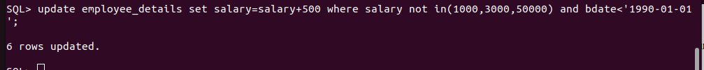
15. Give 100 rupees bonus to employees having salary between 1000, 3000 and 5000 rupees.
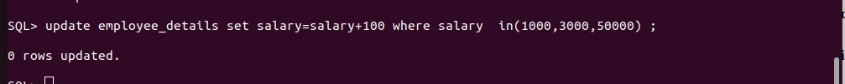
16. Delete from employee the rows having bdate less than 1970.

17. List the name and age of all employees.
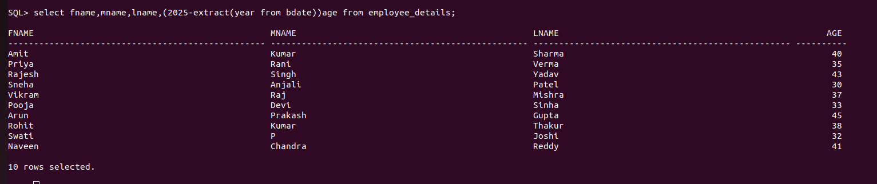

18. Display the salaries offered to the employe
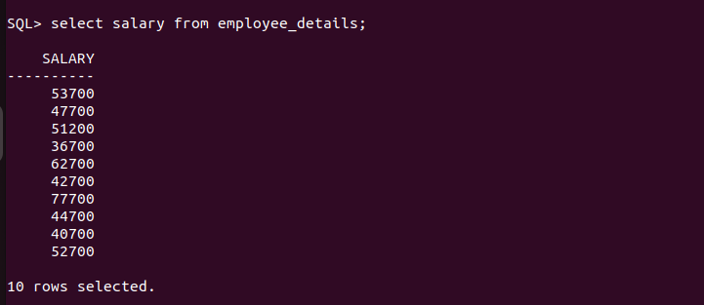
19. List the Bdate and Salary of Employee ‘Smith’.
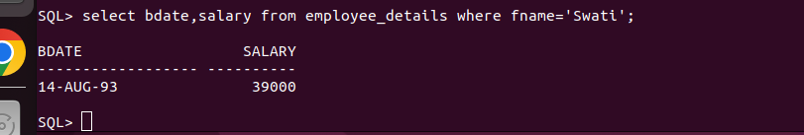
20. Find the location of Project ‘SUPER’.
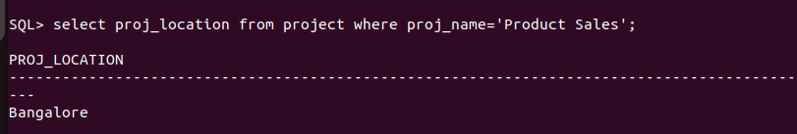

21. Find the dependent details of Employee with Ssn number 482928.

22. List the employees having salary > 2000 and bdate before 1/1/1990.
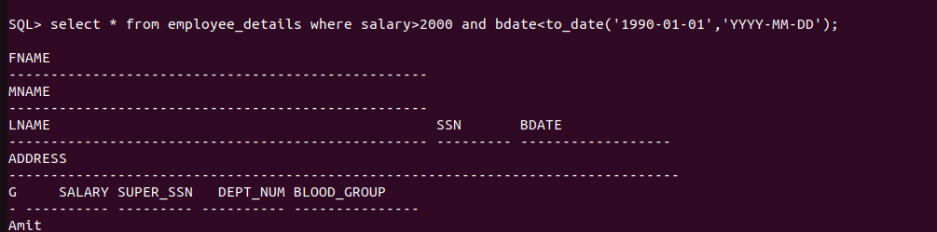
23. List the employees belonging to dept_num 1.
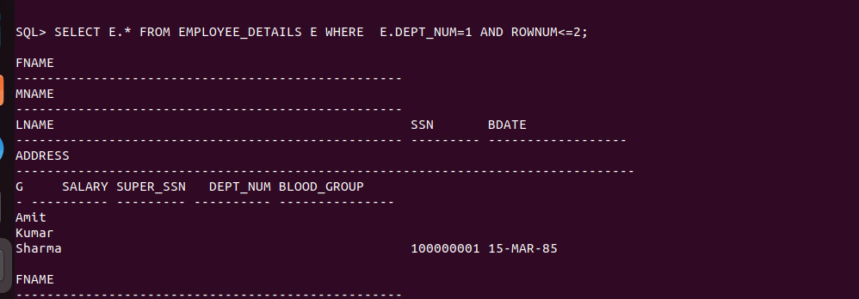
24. List the project details of dept_num 5.
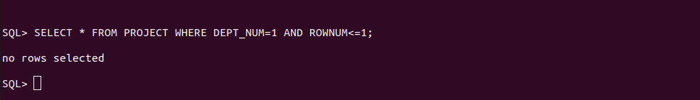
25. List the employee details with their department name.
SELECT E.*,D.DEPT_NAME FROM EMPLOYEE_DETAILS E JOIN DEPARTMENTS D ON D.DEPT_NUM=E.DEPT_NUM;
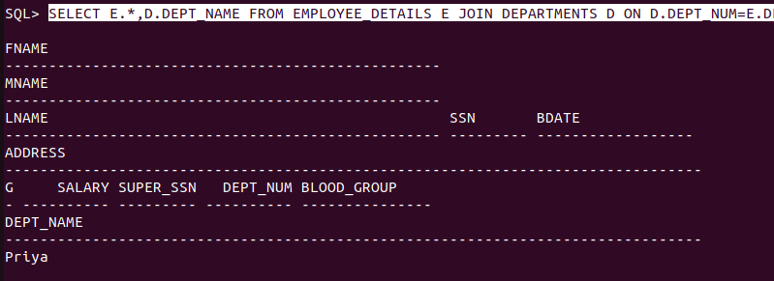
26. List the employee details with their project names.
27. List the employees belonging to Marketing department.
SQL> SELECT E.* FROM EMPLOYEE_DETAILS E JOIN DEPARTMENTS D ON D.DEPT_NUM=E.DEPT_NUM WHERE D.DEPT_NAME='Marketing';
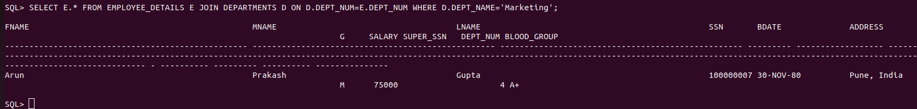
28. List the project details belonging of Sales department.
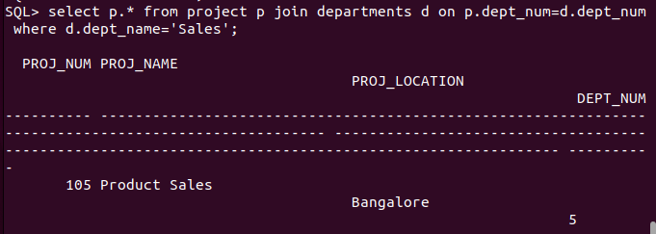
29. List the dependent details of employee ‘Smith’.
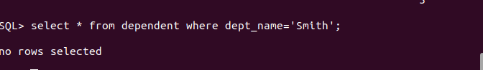
30. List the various locations of ‘Marketing’ department.
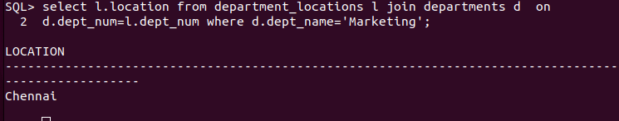

31. List the employees going to ‘Surathkal’ branch.
32. List the employees in the descending order of their salary.
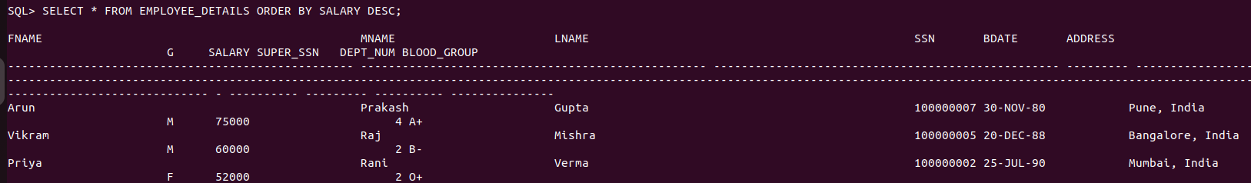
33. List the dependents in the descending order of their names.
